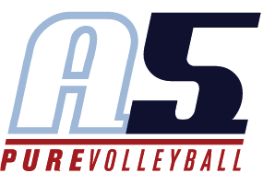

Aneska Arosarena-Kirklen

Head Coach 10 Aneska

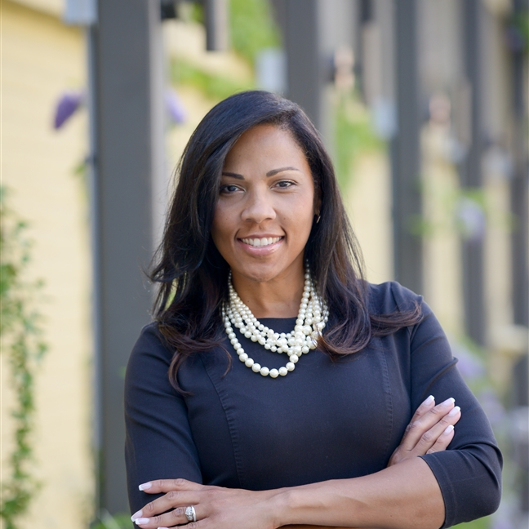

*As a Coach I want to inspire young athletes to dream big and give their best when they step on the court. Help them be mentally and physically strong. Motivate them to release the brilliance that resides in each one of them, which ultimately translates into success in their personal and professional life, as well as, in their team/organization.*

**Coaching Experience**

* St. Mary’s Catholic High School – Neenah, WI - Assistant Volleyball Coach
* Atlanta Boom Volleyball Institute – Atlanta, GA - Assistant Volleyball Coach

**Playing Experience**

**Panama National Volleyball Team – Republic of Panamá**

* Silver Medal – Central American Games
* Played internationally in the Caribbean and Central America

**Purdue University Varsity Volleyball Team – West Lafayette, IN**

* Big Ten Player of the Week –Purdue University
* All-Tournament Purdue Mortar Board Premier
* All Academic Big Ten Honors
* Fiesta Bowl MVP- Phoenix, Arizona

**Hill College Varsity Volleyball Team – Hillsboro, TX**

* All-Conference Team Region Award
* All- Region Honors
* Led her team to the NJCAA Women’s Championship Division 1 Volleyball Tournament in Miami Dade, Florida
* Sophomore Female Most Athletic Awards
* Named MVP of the Region V Conference
* Hill College Hall of Fame Inductee - Class of 2018

**Pan-American Institute IPA (High School) – Panama City, Republic of Panamá**

**Education**

**PURDUE UNIVERSITY - WEST LAFAYETTE, IN**

* B.S. Computer Information Systems Technology, COMPUTER SCIENCE
* M.S Organization Leadership and Supervision
* National Honor Society, Dean’s List
* NCAA Collegiate Athlete – Honor Society – INDIANA IOTA

**Proficiencies/Additional Information**

* Global Innovation & Sustainability Accelerator Senior Manager – Kimberly-Clark Corporation
* Certified Six Sigma - BLUE BELT (CLSBB)
* SALESFORCE.com Certificate of Excellence
* 2010 Marketing Excellence Award Winner
* 2014 Corporate Innovation Award Winner for Best INNOVATION OF THE YEAR Category
* 2014 President of the African American Employee Resource Group Network
* Fluent in Spanish