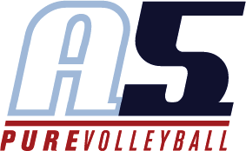

Brett Goblisch

Head Coach 15-3

# Coaching Experience

* A person smiling for the camera

  Description automatically generated with medium confidence2018-2019 A5 Head Coach 11-4 Brett
* 2019-2021 A5 Head Coach 13-5 Brett
  + 1st at Peachtree Classic in 13 Club
* 2022 A5 Head Coach 15-4 Brett
  + 1st in 15 Power at Lil Big South
  + 1st in 15 Liberty at Big South
  + Qualified for USAV in Liberty
* 2016-2018: Head JV Coach, Duluth High School
  + Duties include making and implementing practice plans for the Junior Varsity team
* 2019-Current: Varsity Head Coach, Duluth High School
  + Qualified for the state playoffs in 3 consecutive seasons in 2020, 2021, and 2022
  + Finished 2nd in the region in 2020
  + Finished 3rd in the region in 2021
  + Oversees the entire program including academic performance and personal development
  + Organize and run summer workouts and conditioning
  + Organize and run junior volleyball camps for Duluth Cluster Schools

# Playing Experience

# College intramurals

# Open level adult leagues and tournaments

# Education

* Valdosta State University – Bachelor of Science in Applied Mathematics
* Kaplan University – Master of Arts in Teaching
* USAV Impact Certified
* USAV SafeSport Certification