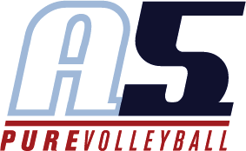Theresa Phelps

Head Coach 13-6

**Why I Coach Volleyball**

As a mom, teacher, and former player, I love children and I love volleyball!  This season, our team will cheer, smile, and have fun as we support one another, while also learning and advancing our skills together. I can't wait to see the amazing progress the team makes during the season, and I am excited to get to know your daughter.

**Coaching Experience**

**A5 2021-2022**

Head Coach, 10U

**Dobbs Creek Recreational Basketball**

Head Coach, 11U

**Cheaha Juniors Volleyball Club**

Head Coach, 14U

# Playing Experience

**Jacksonville State University Volleyball**

* *Division 1 Scholarship Student Athlete*
* *Middle and Outside Hitter*

**Volleyball Atlanta Club (transformed into A5 program)**

* *Southern Region Champions*

**Milton High School Volleyball**

* *Georgia State Runner-Up Champions*
* *Georgia State Volleyball Player of the Year*
* *Georgia All-State Selection, First Team*

# Education

**Jacksonville State University,** *Bachelor of Science in Elementary Education*

**Personal**

My husband James and I have four children: Gracie (15), Jameson (12), Sienna (12), and Lanie (12).  When I’m not teaching or coaching, you can usually find me at the tennis courts as I absolutely love tennis and play three times a week through ALTA and USTA.