

Danielle Abram

Assistant Coach 14-Kip

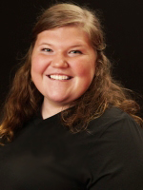**Coaching Experience**

**2019-Present**

* A5 14-Kip Assistant Coach

**2018**

* 2018 A5 Volleyball Club - 14 Candice
* KSU Men’s Club Volleyball

**2017**

* Head Coach CAJ 15 Danielle
* Head Coach CAJ 15 Danielle AAU
* KSU Men’s Club Volleyball

**2016**

* Head Coach CAJ 14 Danielle ATL
* Assistant Coach CAJ 15 Danielle AAU
* KSU Men’s Club Volleyball

**2015**

* Head Coach Crossfire 14-2
* Head Coach CAJ 15 Danielle AAU

**Playing Experience**

* KSU Men’s Club Volleyball
* KSU Women’s Club Volleyball
* Milton High School

**Education**

**Kennesaw State University**

* Bachelor of Arts in English - December 2016