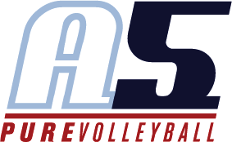Sabrina Rodgers

Assistant 17-1 Jing

Playing experience

Played for Iowa Rockets Volleyball 2006 - 2014

Attended USAV National Championships 2008 - 2014

Top 3 finish at USAV National Championships 2011, 2014

Gold Medal at Show Me National Qualifier 2012

City High School Varsity Volleyball 2012 - 2014

Columbus State University Women’s Volleyball 2014 - 2016

Fort Hays State University Women’s Volleyball 2017

Coaching Experience

Iowa Rockets VBC Winter and Summer Clinics 2013 - present

Iowa Rockets VBC Position Specific Clinics 2013 - present

Assistant Coach COLAVOL VBC 2015 - 2016

Assistant Coach Iowa Rockets VBC (Summer season) 2016 - 2018

* USAV National Championships 2nd Place National Divison 2018

Private and Small Group Lessons 2016 - present

Head Coach Iowa Rockets VBC 13 Black (Summer season) 2017

Head Coach Western Kansas Elite Volleyball 17-2 2018

Assistant Coach Agnes Scott College Women’s Volleyball present

Education

Iowa City High School 2014

Bachelor of Science, Psychology, Fort Hays State University 2018

Master of Sports Administration, Georgia State University present