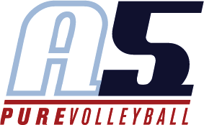

Maureen Smith

Head Coach 13-3

# Coaching Experience

**2018-2019 assistant coach 13-3 Betty**

2017-2018 assistant coach 13-3 Betty

2016-2017: A5 13-3 Head Coach

2015-2016: A5 14-3 Assistant Coach

Fall, 2016-2018: Head Freshman Coach, South Forsyth High School

Fall, 2015: Feeder White team (A team) coach for South Forsyth High School 2014-2015: A5 Volleyball 14-4 Assistant Coach

Top 25 SRVA ranking

2013-2014: A5 Volleyball 14-4 Assistant Coach Top 25 SRVA ranking

Fall, 2010 and 2011: Feeder team coach for South Forsyth High School

# Playing Experience

* 2008 Anderson University, M/RS

Carolinas Conference Champions, NCAA Tournament participants and Most Improved Player

* 2008: A5 18-3 April, M/RS
* 2005-2008: North Forsyth High School, M/RS under Coach Chuck Crawford

# Education

* Anderson University- Liberal Arts
* Perimeter College and university- Liberal Arts
* USAV Impact Certified
* USAV SafeSport Certification