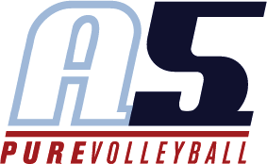



Karen Arndt

Head Coach 13-1 Karen

# Coaching Experience

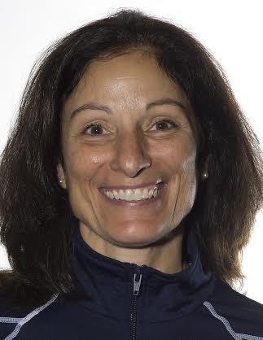**2018**

1. Team Head Coach

Head Coach Marist High School

**2017**

142 Team Head Coach

* Region Champions
* Qualified for USAV Nationals
* Gold medal at Big South Qualifier
* Silver medal in 14s Premier division at AAUs
* Gold Medal – at the 14 National Division at USAV Championships

Head Coach Marist High School

* Area champions
* State Champions in 4A
* Coach of the Year

**2016**

142 Team Head Coach

* Region Champions
* Qualified for USAV Nationals Head Coach Marist High School
* Coach of the Year

# 2015

142 Team Head Coach

* #2 nationally ranked team
* 5th place finish AAU National Championships 14 Premier
* Bronze Medal Disney National Qualifier, 14 Premier division Marist Volleyball Coach, 2015 Fall Season

# 2011-2015

Walker School Head Varsity Volleyball Coach

* Area champion all four season seasons
* State runner-up 2012 (2nd place finish)
* 4th place finish, 2011, 2013

# 2011 to present

A5 Volleyball

* Head coach of 14-2s
* Coached team to SRVA champions in 2012, 2013, 2014
* Two successive teams qualified for USAV Jr Nationals at qualifying tournaments (Mid-East Qualifier, 2014; Disney Qualifier, 2015)

# 2006-2011

A5 Volleyball

* Head volleyball coach of 13-3s, 2007-2009
* Head volleyball coach of 13-2s, 2009-2011

o Qualified for nationals in 2010 and 2011 at the SRVA tournament

School

* Assistant volleyball coach for Lassiter Feeder program, 2005, 2006
* Middle school coach, 2006-2010 Faith Lutheran School (area champions, 2008, 2009)

# Playing Experience

High school

* All-state setter, Bear Creek High School, Lakewood, CO College
* Scholarship to Idaho State University

# Teaching Experience

* Have been teaching in the elementary school classrooms since 1986

# Education

Idaho State University

* Bachelor of Arts in Elementary Education
* Bachelor of Arts in Early Childhood Education

Concordia University, Bronxeville, NY

* Masters of Divinity

•Bachelor of Arts in Elementary Education

Concordia University, Bronxeville, NY

* Masters of Divinity