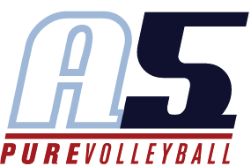

Haley Collins

Head Coach 13-4 and 10-1 Haley

**Coaching Experience**

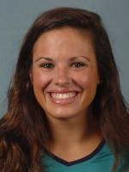

**2015-Present**

A5 Volleyball – Assistant Coach

2015 13-2 Assistant Coach

**2016**

Peachtree Charter Middle School- Head Coach

* 1st place regular season and Cobb Championship Tournament

**2009-2010**

A5 Volleyball- Player Volunteer Coach

12-1 Player Volunteer Assistant Coach

* Helped with the 12-1 while playing for 18-1 (Bob)

VolleyPerformance

* Lead Instructor Camps and Clinics

**Playing Experience**

University of North Carolina Wilmington

* Starting Libero all four years
* 2013 & 2014 Team Captain
* 2012 & 2014 Most Valuable Player
* 2012 & 2013 Defensive Player of the Year
* All-Time Rankings: 2nd- Career Digs, 2nd- Service Attempts, 3rd- Digs Per Set, 8th- Most Sets Played

Wesleyan High School

* High School Captain, All Area and Regional Team Member, Coaches’ Award Recipient (twice)

A5 Volleyball

* 18-1 (Bob), 17-1, 16-1, 15-1, 14-1, 13-1

**Education**

University of North Carolina Wilmington

* Degree in Exercise Science

**Other Information**

I currently am in the process of applying to physical therapy school to earn my Doctorate degree. I work as a trainer for Orange Theory Fitness and previously was employed at Benchmark Physical Therapy. I love to travel and spend time outdoors playing with my two year old golden retriever, Theo.